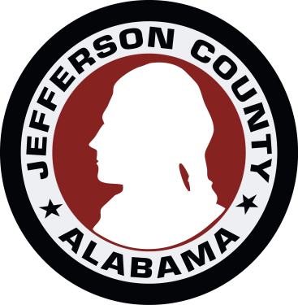

JEFFERSON COUNTY ENVIROMENTAL SERVICES
DEED INSTRUCTIONS

Deeds for Sanitary Sewer Right-of-Ways must be:

1). On our deed form. Copies may be obtained from:

Telephone E-Mail
Kelly Watson 325-1446 watsonk@jccal.org
Richard Mixon 325-5125 mixonr@jccal.org

The deed is available in Microsoft Word and WordPerfect. When requesting by E-mail please specify which version you need.

2). Filled in completely.

3). Notary= statements - on rear of sheet. The first two (2) are for individuals (Private properties) 1 for each owner as necessary; the bottom statement is for corporations or public properties.

4). Type or print legibly the names of individuals and or company=s under their signatures.

5). No Fax copies will be accepted nor any copy that has been faxed . Originals only.

